**OFFICERS DATA SHEET**

**School Year 2023-2024**

**PERSONAL PROFILE**

|  |  |  |  |
| --- | --- | --- | --- |
| **Name** | Zachary Albert Legaria | | |
| **Home Address** | Buhion St., San Isidro | | |
| **City Address** | Tagbilaran | | |
| **Degree Program** | BSIT-3 | | |
| **Mobile No.** | 09170000130 | **Email Address** | legaria.zachary_albert@hnu.edu.ph |
| **Date of Birth** | **Age** | **Civil Status** | **ID No.** |
| October 24, 2002 | 19 | Single | 06752682 |

|  |  |  |
| --- | --- | --- |
| **In case of emergency, please notify:** | | |
| **Complete Name** | **Address** | **Contact Number** |
| Sarah Jane Magallanes | Buhion St., San Isidro | 09171361799 |

1. ACADEMIC PERFORMANCE

|  |  |  |  |
| --- | --- | --- | --- |
| **Educational Level** | **Institution** | **Inclusive Years** | **Honors / Awards** |
|  |  |  |  |
| SHS Grade 11 | Tagbilaran City Science High School | S.Y. 2018-2020 | With honors |
| Grade 9 | Holy Name University | S.Y. 2017-2018 | 6th honor |
| Grade 2 | Little Angels Montessori School | S.Y. 2010-2011 | 4th honor |

1. AFFILIATION IN OTHER ORGANIZATIONS

B.1 In-Campus

|  |  |  |
| --- | --- | --- |
| **Name of Organization** | **Position** | **Inclusive Year** |
| COECS-LGU | 2nd year Representative | 2022-2023 |
| GDSC-HNU | Asst. Junior Programmer | 2022-2023 |
|  |  |  |

B.2 Off-Campus

|  |  |  |
| --- | --- | --- |
| **Name of Organization** | **Position** | **Inclusive Year** |
| Sandugo Leo Club | Member | 2023-2024 |
|  |  |  |

1. SEMINARS / SPECIAL TRAINING ATTENDED

|  |  |  |  |
| --- | --- | --- | --- |
| **Title** | **Description** | **Sponsoring Group** | **Inclusive Dates** |
| Lead Camp | Leadership Training for all CSG officers | HNU CSG |  |
| HSLS | Leadership Training for all RSO Officers | HNU CSO | Aug 4-6 ,2023 |

|  |  |
| --- | --- |
| **SIGNATURE** | **DATE** |
|  |  |

**ATTACHMENTS**

**CURRENT STUDY LOAD**

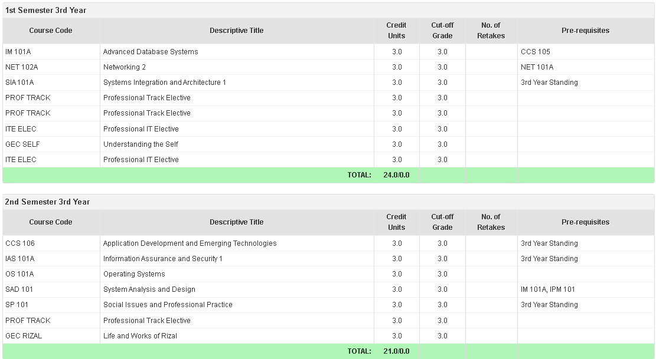

**GRADES (PREVIOUS S.Y. | 1ST & 2ND SEMESTER)**

